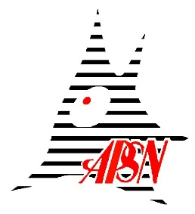

Application Form for Young Investigator Colloquium

17th Meeting of the Asian-Pacific Society for Neurochemistry (APSN2023), Singapore
19-21 June, 2023
*Please submit the completed form to: secretariat@apsn2023.sg

- Applicant’s Particulars:

Name Of Applicant | (First Name) | (Last Name)
Affiliation & Weblink
Institution
Country
Email Address
Years of experience since Ph.D

- Information of Research Proposal:

- Title Of Talk
- Abstract
- Significance of the topic and talk

- Short CV of YIC with a selection of up to 5 representative publications

- Previous awards from ISN/APSN

